NAAN MUDHALVAN

TITLE : WORDPRESS CREATION

USER NAME : CB03D9275A8AE558C2F4B39295145681

1.open the facebook login

2.create a business acout page

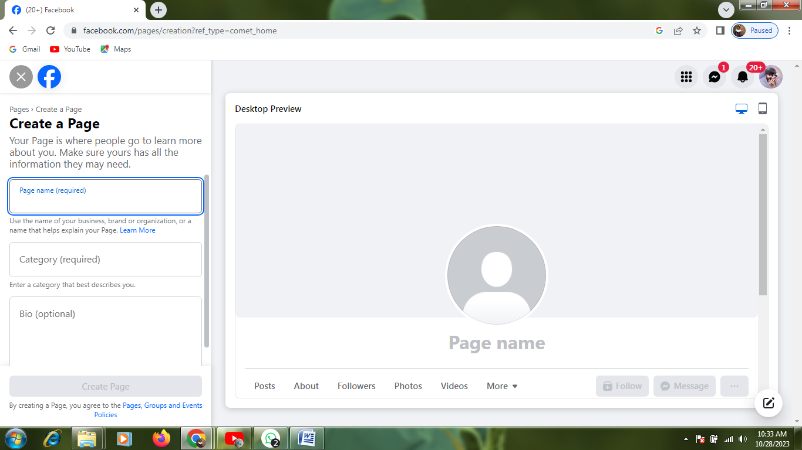

3.upload the details

(1) images

(2) contact details and description writing

For example:

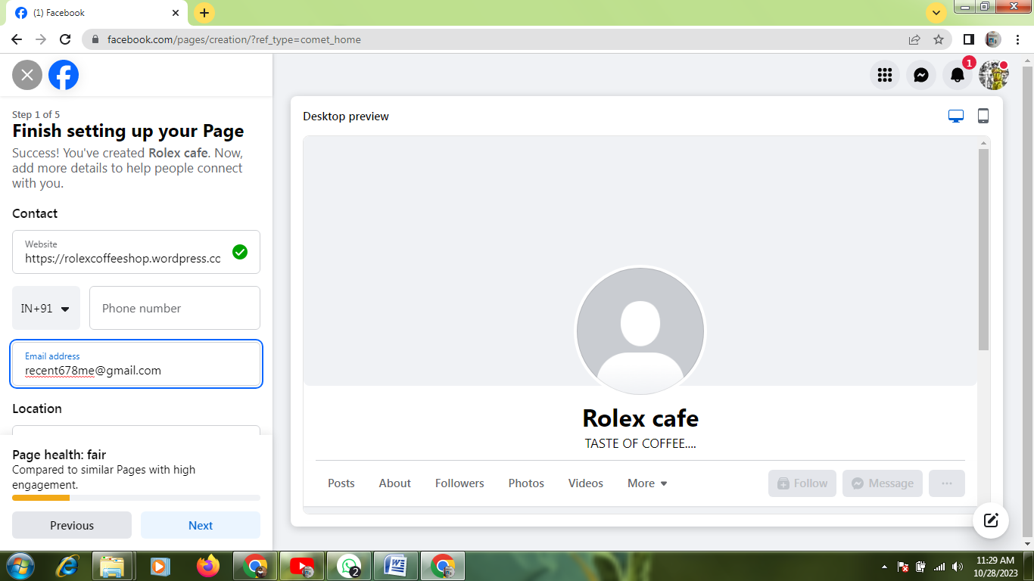

4.business home page created

